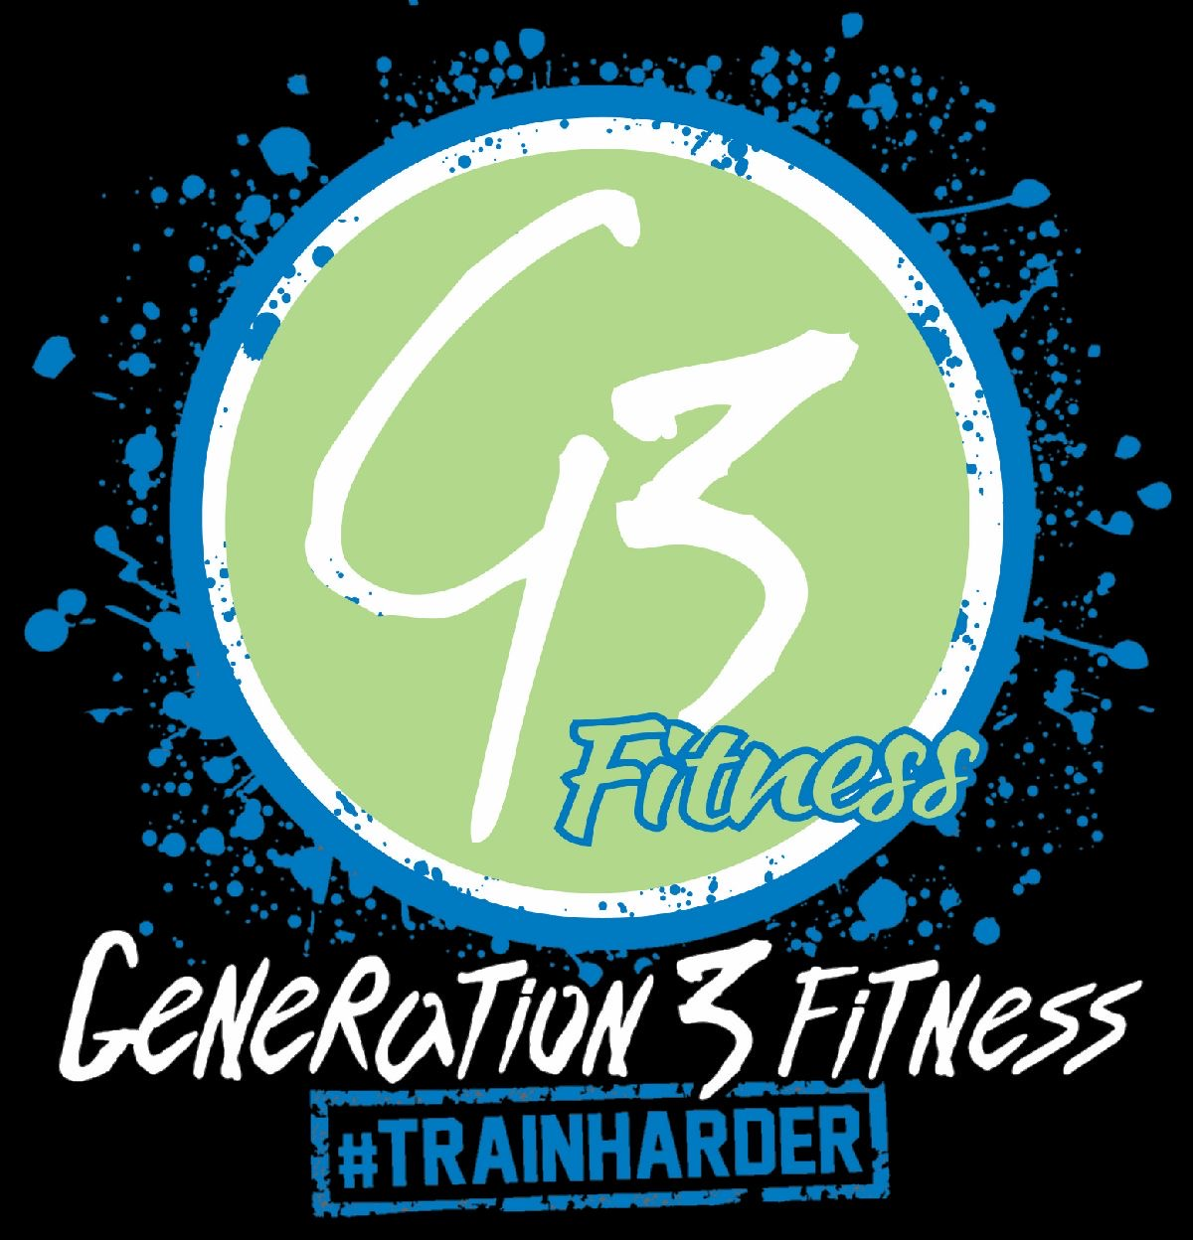

WHAT TO EXPECT AT YOUR TRY TRAINING SESSSION…

Before session:
- Make a list of any current / previous health conditions
- Create a log of your current dietary intake
- Make a list of any medications and supplements that you are currently using
- Make a list of any questions you may have before starting your fitness journey

Day of session:
- Wear comfortable fitness clothing
- Wear tennis shoes or sneakers. Avoid any footwear that has air bubbles or are uneven to walk in
- Wear your Fitbit or heart rate monitor if you have one
- Bring a water bottle and hand towel
- Have a light healthy snack about 30 minutes prior to your session (banana, apple, berries)
- Be well hydrated

WHAT TO EXPECT AT YOUR TRY TRAINING SESSION…

Session 1 arrival:
- Enter gym through the Lindbergh entrance to meet your trainer (5900 N. Lindbergh BLVD. Hazelwood, MO 63042)
- Trainer will give you a gym tour
- Fill out health assessment questionnaire
- Sit down consultation with trainer to discuss health assessment and discuss fitness goals
- Fitness assessment (movement assessments, muscular endurance, muscular strength, flexibility & range of motion and cardiovascular health)
- Schedule session 2

Session 2 arrival:
- Enter gym through the Lindbergh entrance to meet your trainer (5900 N. Lindbergh BLVD. Hazelwood, MO 63042
- Warmup for session 2 workout in cardio room
- Fitness assessment continued (machine work and movement assessment continuation)
- Discuss program ideas for how to reach your goals and services that fit into your lifestyle
- Share training packages within your budget and get you started

